Model Summary and Accuracy h

1. Name and type of all 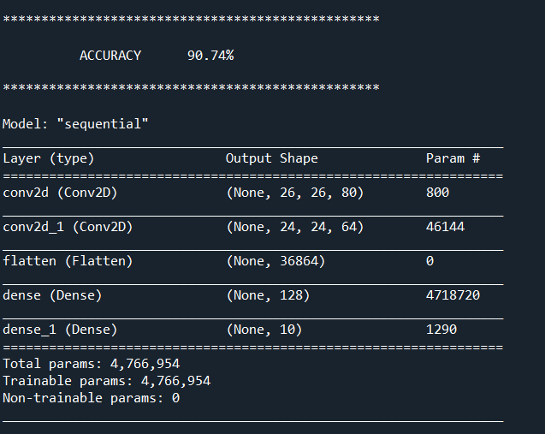layer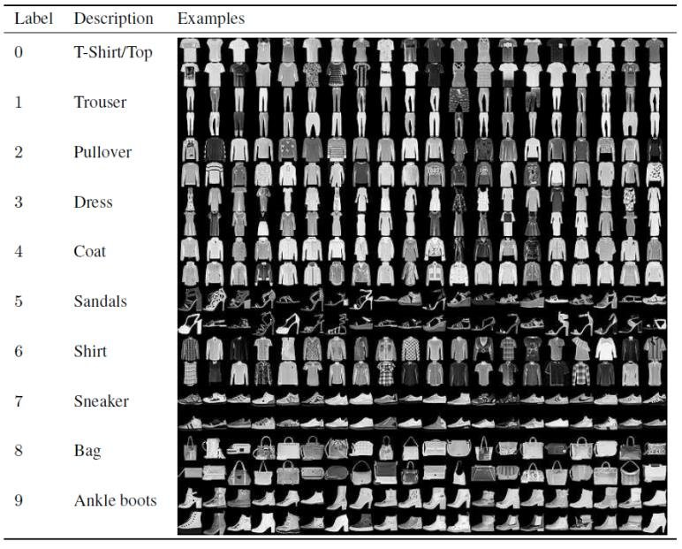s in the

**MODEL SUMMARY**

Summary () method is used to print the summary of the model, which includes:

1. Name and type of all layers in the model.

2. Output shape for each layer.

3. Number of weight parameters of each layer.

4. If the model has general topology, the inputs each layer receives.

5. The total number of trainable and non-trainable parameters of the model.

**DATA SUMMARY**

Brief picture of what data consists of.